Grade 11 English FAL 11 to 15 May 2020
- Day 1 – Worksheet 1 Prepositions
- Day 2 – Worksheet 2 Verb agreement/concord
- Day 3 – Worksheet 3 Comprehension (visual texts)
- Day 4 and 5 – Worksheet 4 Descriptive essay
Worksheet 1 11 to 15 May 2020 (1 day)
Prepositions
A word usually used before a noun or pronoun that indicates some relationship between that noun or pronoun and another in the sentence, e.g. The man (noun) hides under the table (another noun) – the preposition indicates where the man (noun) is relative to the table (another noun). Pronouns include words like for, on, in, from, between, to and at.
Exercise
Give the correct preposition be used in the blank spaces below:
- It was hard ____ the teenagers to stay at home.
- The awkward boy continued ____ be teased.
- Harry looked ____ us and smiled broadly.
- I was going ____ the movies ____ my friends.
- I was upset ____ the spread of Covid 19.
- I was with my friends ___ the beach when Sally jumped ____ me and tickled me.
- I crept ____ the house after sneaking ____ to see my friends.
- I had hoped the lock-down would give me a break ____ school work.
- I was free ____ spirit even though I was confined ____ home.
- They kicked the ball ____ the rugby field.
- My friend was happy that I had left his name out ____ my story.
- The man drew pictures ____ men smiling ____ women.
- I could never make up my mind ____ him.
- A friend would never give you a slap ____ the face!
- My friends had left ____ home when an army vehicle turned ____ the corner and caught me alone ____ the street.
- Living ____ Pretoria North is a privilege as many people want ____ do so.
- We ran ____ the field and smiled ___ our friends who had finally arrived.
- The teacher caught me ____ the arm as I was about to fall ____ the balcony.
- My friend turned the hose ____ me the moment I flung myself ____ my father’s arms, drenching us both.
- My friend has played many pranks ____ me, calling and pretending ____ be someone else.
Worksheet 2 11 to 15 May 2020 (1 day)
Verb agreement (concord)
Verb agreement or concord involves using the correct verb (singular or plural) for the subject (active person or thing) in the sentence (He is/They are, etc.).
Some basic rules include the following:
- The singular or plural nature of the subject will not change due to words between the subject and verb, e.g. One of the glasses is empty, OR The bouquet of roses smells wonderful.
- The verb in a sentence containing “or”, “either/or”, “neither/nor” agrees with the noun or pronoun closest to it, e.g. Either the man or his sons are responsible, OR Neither the girls nor Jack was guilty of breaking the curfew.
- When the subject is followed by words such as “as well as”, “along with”, “besides”, “not” etc. ignore them and use a singular verb if the subject is singular, e.g. Jack, as well as his friends, is expected soon, OR Jason, along with his class members, is very responsible.
- Sentences that include sums of money, periods of time, fractions and distances use singular verbs, e.g. Five hundred years is a long time, OR A quarter of the cake was missing.
Exercise
Choose the correct words from the brackets:
- Either Jack or his friends (is/are) responsible for this.
- The Olympic Games (was/were) wonderful to watch.
- Macaroni and cheese (is/are) to be placed on my shopping list.
- Neither of the police officers (was/were) able to arrest the thief.
- A large number of people (is/are) coming to my party.
- One out of twenty school children (is/are) going to land up in jail one day.
- More than one friend (has/have) betrayed me.
- The number of learners who always do their homework (is/are) disappointing.
- Thirty percent of the population (is/are) unemployed.
- The reference books containing the information I require, (is/are) not available.
- The advocate or lawyers representing an accused in court (has/have) the responsibility to try and prove his innocence.
- The prison wardens together with the social worker (tries/try) to rehabilitate prisoners.
- Three fifths of the staff members (was/were) late.
- Resources, including a library book, (has/have) to be listed at the end of your project.
- Fish and chips (has/have) to be freshly prepared for one to enjoy it.
Worksheet 3 11 to 15 May 2020-05-08 (1 day)
Comprehension (visual texts)
Text A
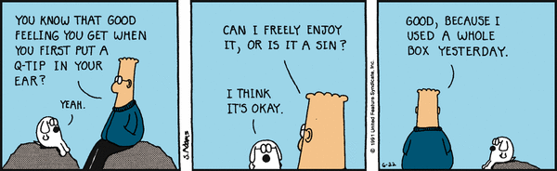

- Comment on the personality type of the two characters in the cartoon. Refer to a visual clue, as well as a clue from the text.
- Explain the irony in the cartoon.
- Give a suitable heading of your own for the cartoon.
- Would you regard the man in the cartoon as very conservative or very liberal? Give a reason for your answer.
- Identify the tone of the conversation.
- Identify the register of the words of the character with glasses on and explain why you say so.
- Would you describe the two characters as being close? Provide two reasons for your answer.
- Provide an adjective that would best describe the character with glasses.
- Identify a preposition used in Frame 1.
- Can the cartoon be described as humorous? Explain.

Text B
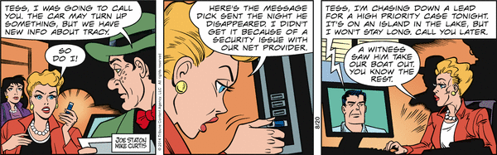
- Identify when in history (i.e. during the time of the Voortrekkers) this cartoon is set and give a reason for your answer.
- Comment on the relationship the other characters have with the blonde lady and refer to the text to justify your answer.
- Describe the image projected by the blonde lady and refer to both visual and a textual clues to justify your answer.
- Say what is suggested about the two men in the cartoon by the way they are drawn. Give reasons for your answer.
- Suggest what genre the cartoon represents.
- Name the purpose of the cartoon.
- Study the cartoon and try to describe its intended target audience as fully as possible.
- In Frame 2 the lady appears stressed. Describe the visual clues that suggest this.
- Are there any gender stereotypes visible in the cartoon? Explain your answer.
- Would other cartoons such as this one appeal to you? Explain why.
Worksheet 4 11 to 15 May (2 days)
Writing a descriptive essay
Day 1 – plan and write a first draft.
Day 2 – edit your first draft and write a final draft.
The descriptive essay should describe something rather than tell a story. Remember to describe using
- your different senses (what you see, taste, feel, hear and smell);
- adjectives and adverbs;
- expressive rather than boring nouns and verbs (“hulk” rather than “man”, “raced” rather than “ran”, “stunning” rather than “nice”);
- involve action rather than just static descriptions (“The naturally camouflaged stick insect hesitantly crawled up the rough, olive, moss-covered bark of the thorn tree” rather than, “The bark of the thorn tree was covered in moss”).
Write a descriptive essay of 200 to 250 words on one of the following topics:
- Waking up late one morning at home during the Covid 19-necessitated lock-down.
- My favourite food.
- Watching a lock-down concert by a favourite artist on TV at home.
- Our garden.
- Boredom.

